**Exercise 1: Configuring a Basic Spring Application**

**BookRepository.java**

**package** com.library.repository;

**public** **class** BookRepository {

**public** **void** saveBook(String bookName) {

System.***out***.println("Book saved: " + bookName);

}

}

**BookService.java**

**package** com.library.service;

**import** com.library.repository.BookRepository;

**public** **class** BookService {

**private** BookRepository bookRepository;

**public** **void** setBookRepository(BookRepository bookRepository) {

**this**.bookRepository = bookRepository;

}

**public** **void** addBook(String bookName) {

bookRepository.saveBook(bookName);

}

}

**LibraryApp.java**

**package** com.library;

**import** org.springframework.context.ApplicationContext;

**import** org.springframework.context.support.ClassPathXmlApplicationContext;

**import** com.library.service.BookService;

**public** **class** LibraryApp {

**public** **static** **void** main(String[] args) {

ApplicationContext context = **new** ClassPathXmlApplicationContext("applicationContext.xml");

BookService bookService = context.getBean("bookService", BookService.**class**);

bookService.addBook("Alchemist");

((ClassPathXmlApplicationContext) context).close();

}

}

**OUTPUT:**

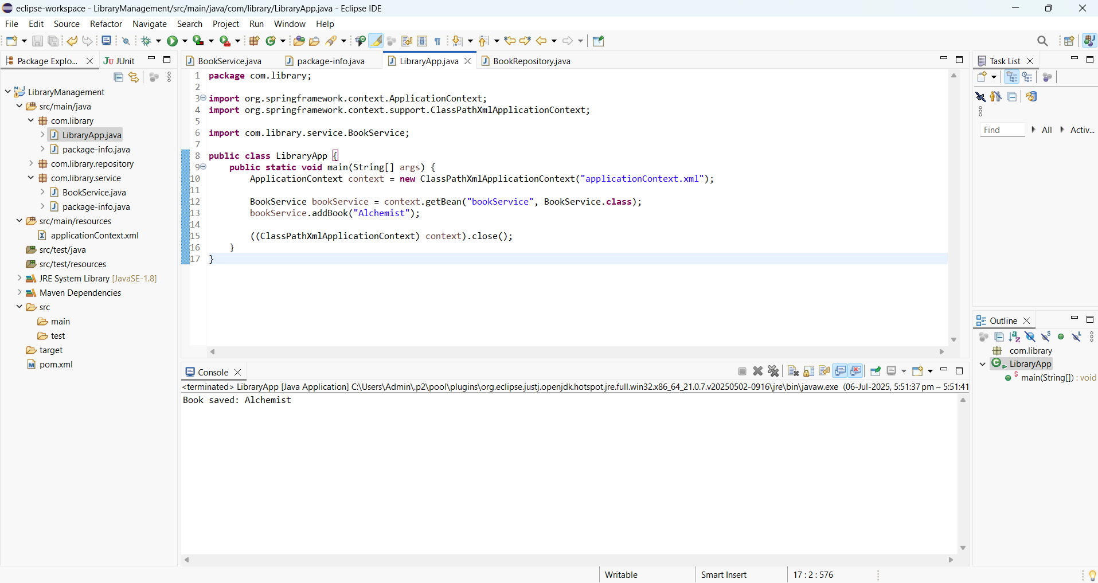

**Exercise 2: Implementing Dependency Injection**

**BookService.java**

package com.library.service;

import com.library.repository.BookRepository;

public class BookService {

private BookRepository bookRepository;

public void setBookRepository(BookRepository bookRepository) {

this.bookRepository = bookRepository;

}

public void addBook(String bookName) {

System.out.println("BookService: Adding book -> " + bookName);

bookRepository.saveBook(bookName);

}

}

**BookRepository.java**

package com.library.repository;

public class BookRepository {

public void saveBook(String bookName) {

System.out.println("BookRepository: Book saved -> " + bookName);

}

}

**LibraryApp.java**

package com.library;

import org.springframework.context.ApplicationContext;

import org.springframework.context.support.ClassPathXmlApplicationContext;

import com.library.service.BookService;

public class LibraryApp {

public static void main(String[] args) {

ApplicationContext context = new ClassPathXmlApplicationContext("applicationContext.xml");

BookService bookService = context.getBean("bookService", BookService.class);

bookService.addBook("The Pragmatic Programmer");

((ClassPathXmlApplicationContext) context).close();

}

}

**OUTPUT:**

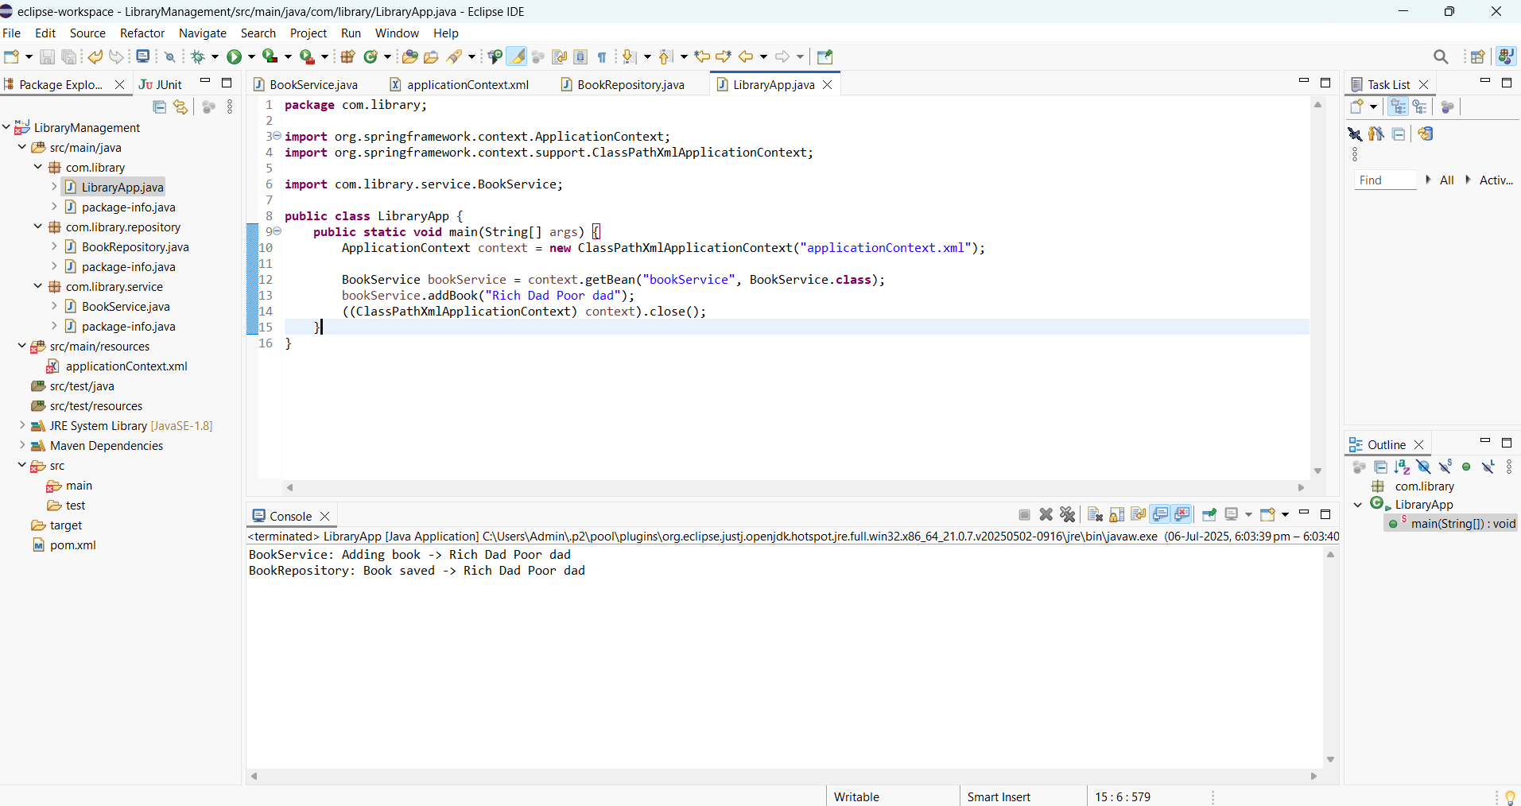

**Exercise 4: Creating and Configuring a Maven Project**

**OUTPUT:**

